**HR Dashboard - Supply and Demand Gap Analysis**

**Overview:**   
This case study focuses on performing a supply and demand gap analysis using an HR dataset. The aim is to identify gaps between the demand for and supply of talent within the organization, enabling actionable insights to optimize talent management strategies. The analysis utilizes various charts in Power BI, including marks cards, bar charts, tables, comparison charts, stacked bar charts, donut charts, funnel charts, and pie charts, to gain insights into employee demographics, job satisfaction, salary trends, and distance from home.

**Aim:**

The aim of this project is to perform a supply and demand gap analysis using an HR dataset. By analyzing various factors such as employee demographics, job satisfaction, salary trends, and distance from home, we can identify gaps between the demand for and supply of talent within the organization.

**Introduction:**

Supply and Demand gap analyses are widely used by companies as strategic management decision tools. This project focuses on identifying the gap between demand and supply to enable the organization to take action and minimize those gaps. We utilize an HR dataset to gain insights into the workforce composition, salary trends, job satisfaction levels, and other relevant factors.

**Problem Statement:**

The organization aims to identify any disparities in gender-based salary, understand job satisfaction levels, analyze the age distribution, and assess the impact of distance from home on the workforce. The objective is to provide actionable insights and recommendations to address these issues and optimize talent management strategies.

**Methodology:**

The analysis is based on an HR dataset that includes various employee-related fields. We employ different visualization techniques in Power BI, such as marks cards, bar charts, tables, comparison charts, stacked bar charts, donut charts, funnel charts, and pie charts, to gain insights into the desired areas. The data is aggregated and summarized using appropriate measures and filters to facilitate analysis.

**Analysis:**

1. Marks Cards Chart:

- Total number of employees in the organization: The analysis reveals the overall workforce size, enabling an understanding of the scale and resource allocation needs of the organization.

- Number of job roles: This analysis provides insights into the diversity and complexity of the organization's structure, aiding talent management and career development strategies.

- Average age: Examining the average age of employees helps understand the generational composition within the organization, enabling knowledge transfer and fostering diversity and inclusion.

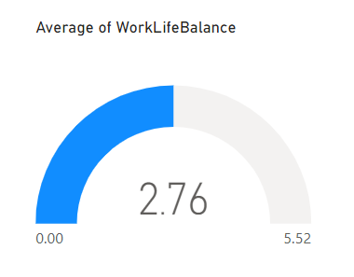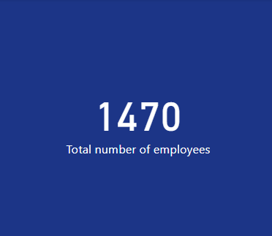 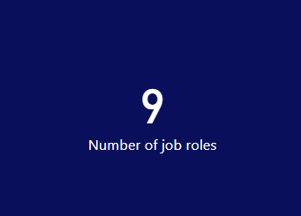

2. Bar Chart with Slicer:

- Average percent salary hike by gender: By visualizing the salary increases by gender, we identify any disparities and can take steps to ensure equitable compensation practices.

- Slicer for job role: Incorporating a slicer allows interactive filtering to examine salary trends within specific job roles, providing insights into variations in salary growth across positions.

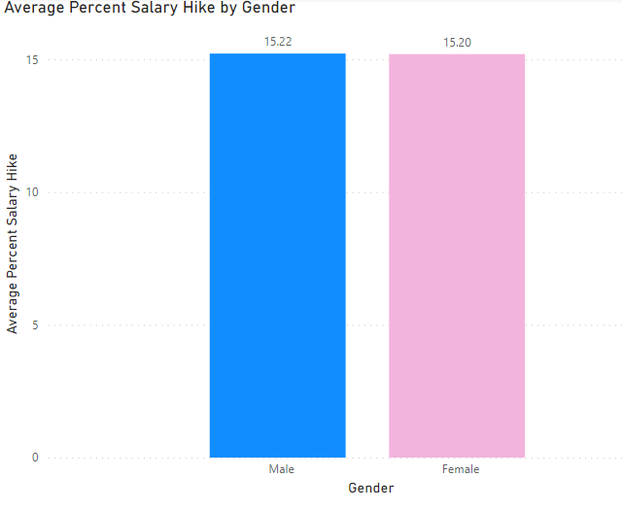

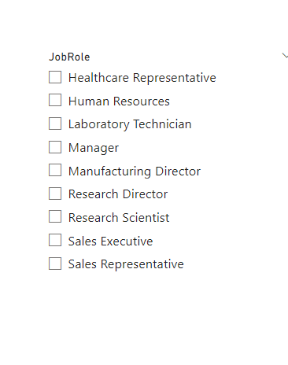

3. Tables Chart:

- Education fields and monthly income: Analyzing the relationship between education fields and income levels provides insights into the impact of education on salaries, aiding talent acquisition and training programs.

- Average percent salary hike, sum of employees, and job roles: This comprehensive overview helps identify salary trends, understand the workforce composition, and distribution across roles.

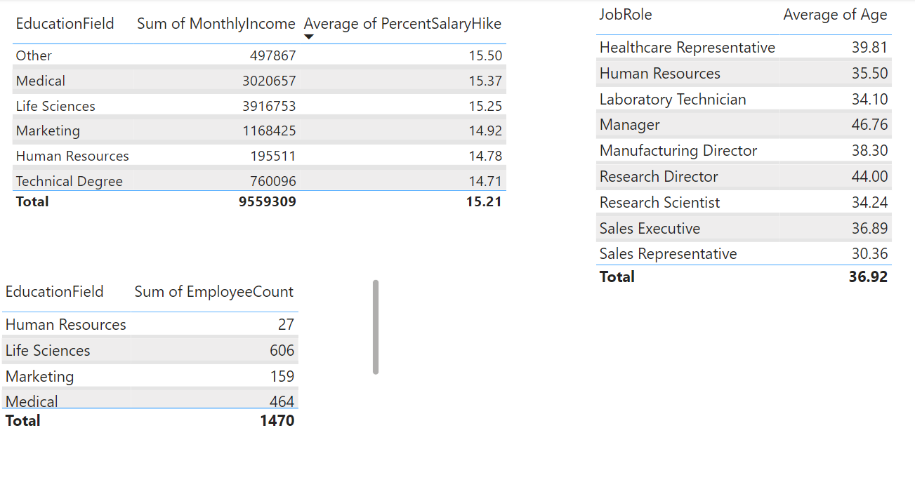

4. Comparison Chart:

- Job satisfaction by gender: Analyzing job satisfaction levels by gender helps identify potential discrepancies and informs targeted initiatives to address any gaps.

- Average age and average total working hours: Examining these factors provides insights into workforce dynamics, productivity, and potential intergenerational collaboration opportunities.

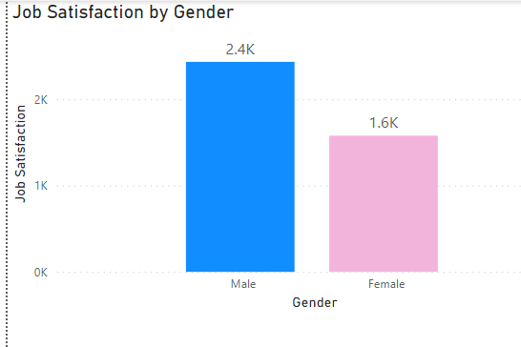

6. Stacked Bar Chart:

- Number of employees by distance from home: Analyzing the distribution of employees based on distance from home helps identify patterns, commuting challenges, work-life balance considerations, and potential impacts on employee retention.

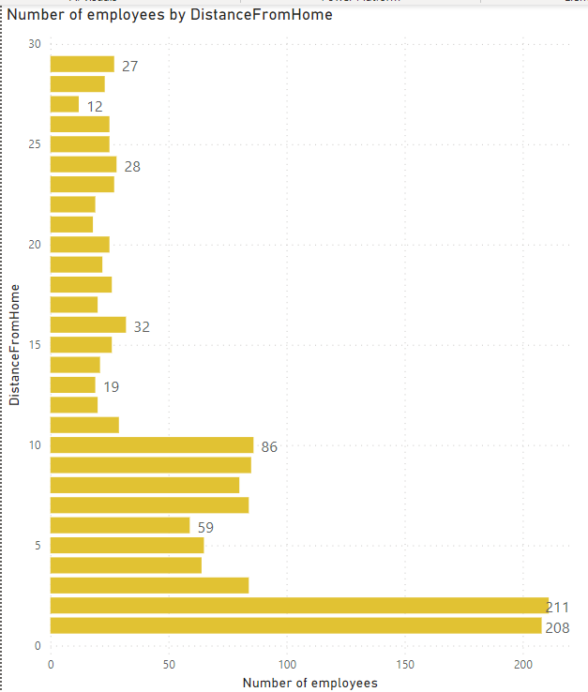

9. Donut Chart:

- Job role by gender: Visualizing the gender composition within each job role helps identify any imbalances or biases, informing diversity and inclusion strategies to promote equal opportunities and representation.

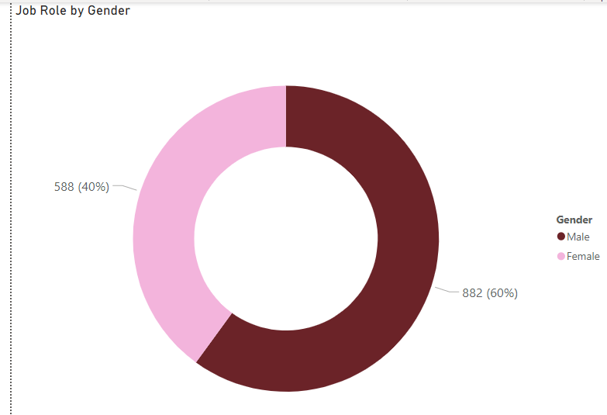 

11. Pie Chart:

- Performance rating by gender: This analysis provides insights into any variations in performance ratings based on gender, highlighting potential biases and areas for improvement.

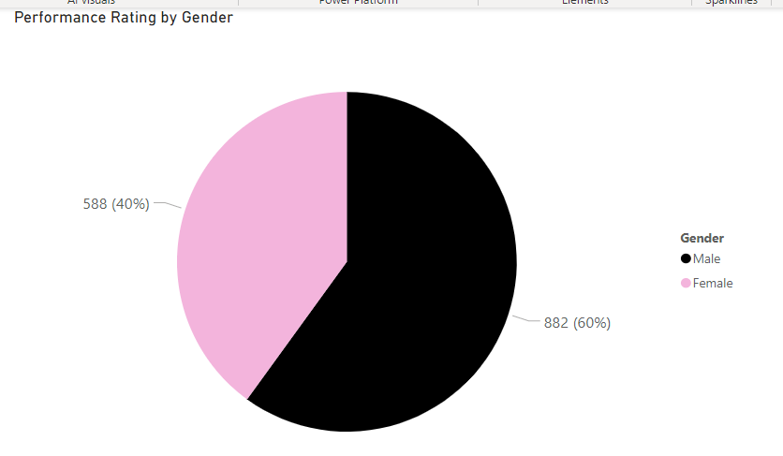

**Insights:**

- Gender-based salary disparities exist, necessitating a comprehensive gender pay gap analysis to ensure equitable compensation practices.

- Job satisfaction levels vary between genders, indicating the need for targeted initiatives to address factors affecting satisfaction for each gender.

The age distribution within the organization is diverse, presenting opportunities for intergenerational collaboration and knowledge sharing.

Geographical distribution of employees reveals clusters based on distance from home, impacting commuting challenges, work-life balance, and employee well-being.

**Recommendations:**

Conduct a gender pay gap analysis to identify and address any salary disparities, ensuring fair and equal compensation practices.

Implement gender-specific initiatives to improve job satisfaction, considering work-life balance, career development opportunities, and inclusive workplace practices.

Develop training and development programs to support employees in enhancing their skills and qualifications, particularly in education fields impacting income levels.

Foster intergenerational collaboration through mentorship programs and knowledge-sharing initiatives, leveraging the diverse age groups within the organization.

Address commuting challenges by offering flexible work arrangements, remote work options, or considering office location strategies to enhance employee satisfaction.

**Conclusions:**

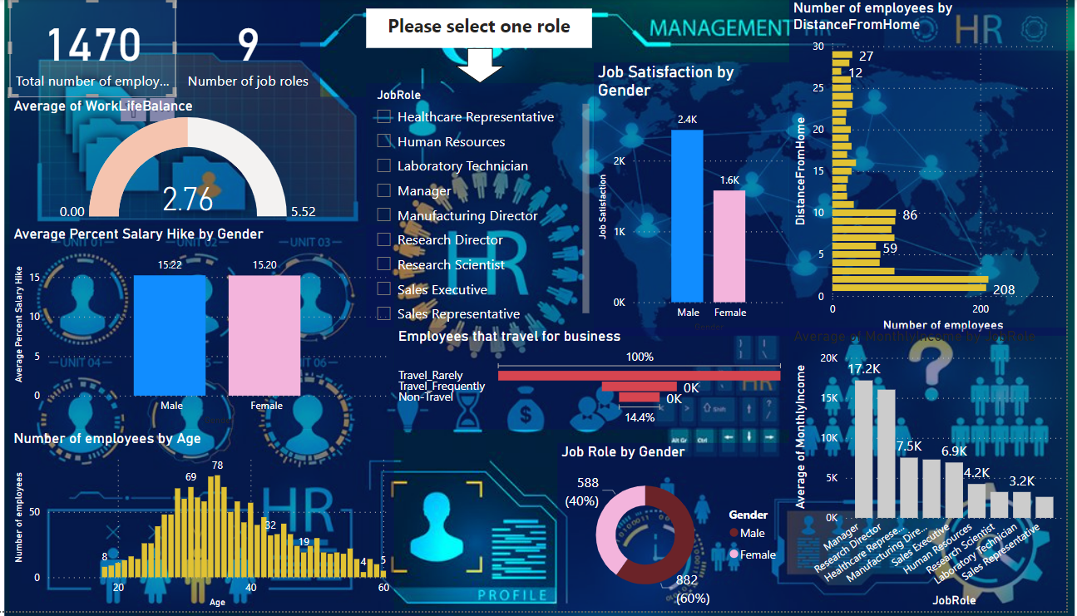By leveraging the HR dataset and employing various visualizations, we have gained valuable insights into the organization's workforce composition, salary trends, job satisfaction levels, and other factors. The analysis highlights the importance of addressing gender-based salary disparities, fostering job satisfaction, leveraging intergenerational collaboration, and addressing commuting challenges. Implementing the recommended strategies will support talent management, diversity, and inclusion efforts while improving employee satisfaction and organizational performance.